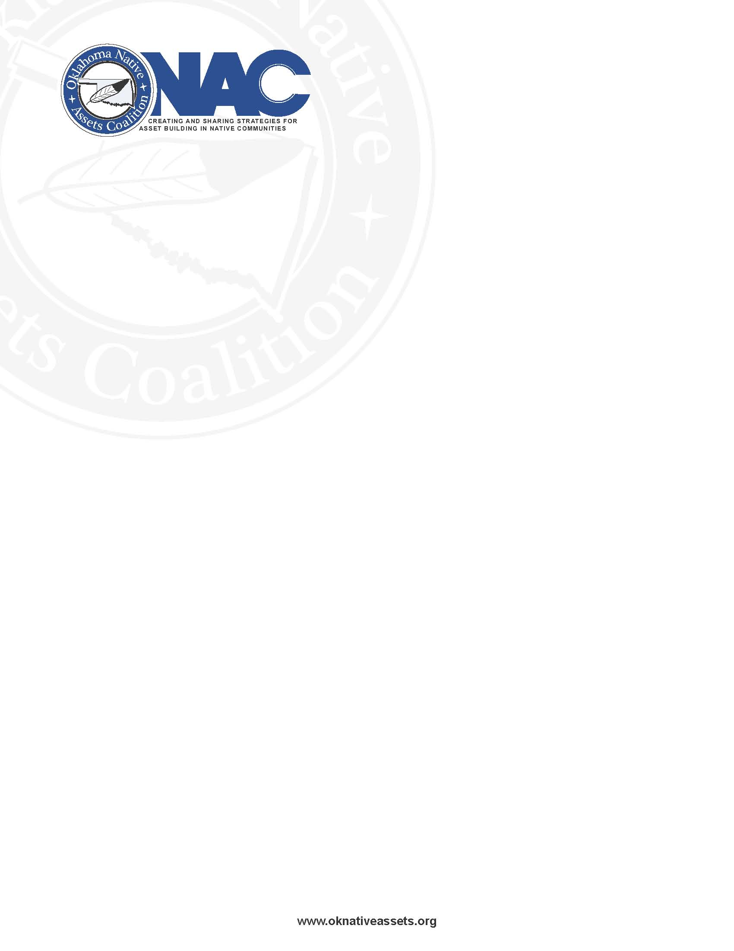

## Native Bank On ONAC

Native Bank On ONAC, begun in 2019 by the Oklahoma Native Assets Coalition, is the first Native-led Bank On initiative/coalition in the country. Native Bank On ONAC works to introduce financial institutions, tribal governments, and other Native-led or Native-focused entities and organizations to the benefits and process of developing and promoting a transactional financial account that meets Bank On National Account Standards (NAS). We facilitate efforts to certify the accounts and introduce the certified accounts into Native communities – often in partnership with a variety of Native-led social or financial programs. NAS certified accounts can save Native citizens hundreds of dollars in costs and fees that are typically associated with alternative financial services, per year.

Bank On safe and affordable NAS certified accounts are most often “checkless” accounts and must meet a specific set of criteria that includes:

* **No or low minimum opening deposit (must be $25 or less)**
* **No or low-cost attached fees, including monthly maintenance fees (total account fees charged cannot EXCEED $5 per month or $60 per year)**
* **Access to the financial institution and all its branches (if no branches, access to free ATM network use and free remote deposits)**
* **Free deposits, free withdrawals, and a free bill pay feature (no charges for in network ATM usage)**
* **The accounts do not allow overdraft or non-sufficient fund fees**
* **Insured account deposits by FDIC or NCUSIF**
* **Financial institutions are encouraged to accept tribal IDs as identification**
* **Other criteria and general information about Native Bank On ONAC can be found on ONAC’s web page at** [Native Bank On ONAC (oknativeassets.org)](http://www.oknativeassets.org/our_work/Native-Bank-On-ONAC)

Bank On is a national program instituted by the Cities for Empowerment Fund (CFE Fund), and supports 84 coalitions nationwide, with over 60 banks or other financial institutions offering certified accounts at over 22,000 branches.

Native Bank On ONAC works with interested financial institutions and tribes across the country, including Native-owned financial institutions – some with a localized or regional service area and some with a national service scope.

**For more information, please feel free to contact Karen Edwards at kedwards@oknativeassets.org**