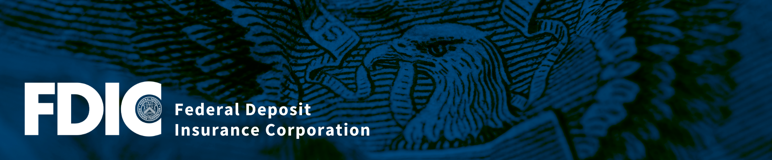

Asset Building in North and South Dakota Native American Communities
Via Webinar
Tuesday, February 28, 2023
1:00 PM to 2:30 PM CST

Agenda

1:00 PM Opening Remarks
Carla Tillmon, Community Affairs Specialist,
Federal Deposit Insurance Corporation

1:10 PM Asset Building in Native American Communities
Christy Finsel, Executive Director, ONAC
Karen Edwards, Manager, Native Bank On ONAC
Oklahoma Native Assets Coalition (ONAC)

1:35 PM VITA (Volunteer Income Tax Assistance) Practitioner Perspective
Jonathan Anderson, TBIC Director (Tribal Business Information Center) Sitting Bull College, North Dakota

1:50 PM Asset Building in South Dakota Native American Communities
Barbara Schmidt, Executive Director
Black Hills Community Loan Fund

2:10 PM Questions & Answers

2:25 PM Next Steps

2:30 PM Webinar Ends

